1. [SELECT](http://localhost/phpmyadmin/url.php?url=https://dev.mysql.com/doc/refman/8.0/en/select.html" \t "mysql_doc) \* FROM `obat` ORDER BY nama\_obat DESC;

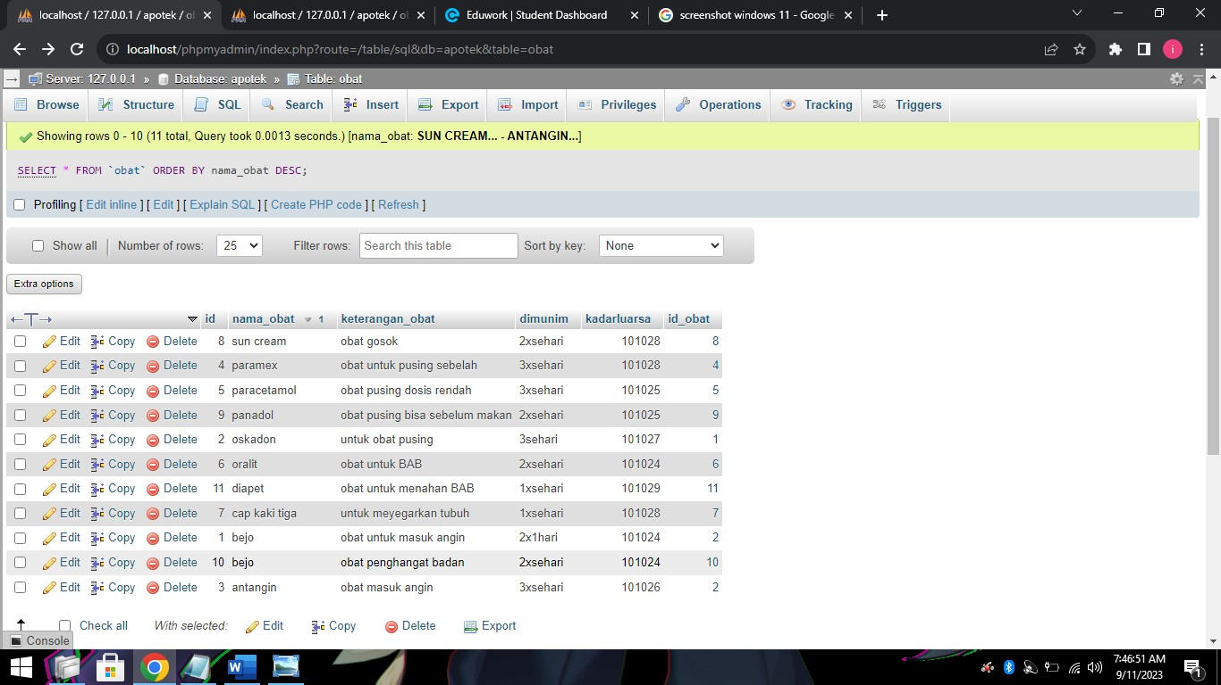

1. [SELECT](http://localhost/phpmyadmin/url.php?url=https://dev.mysql.com/doc/refman/8.0/en/select.html) \* FROM `obat` ORDER BY nama\_obat ASC;

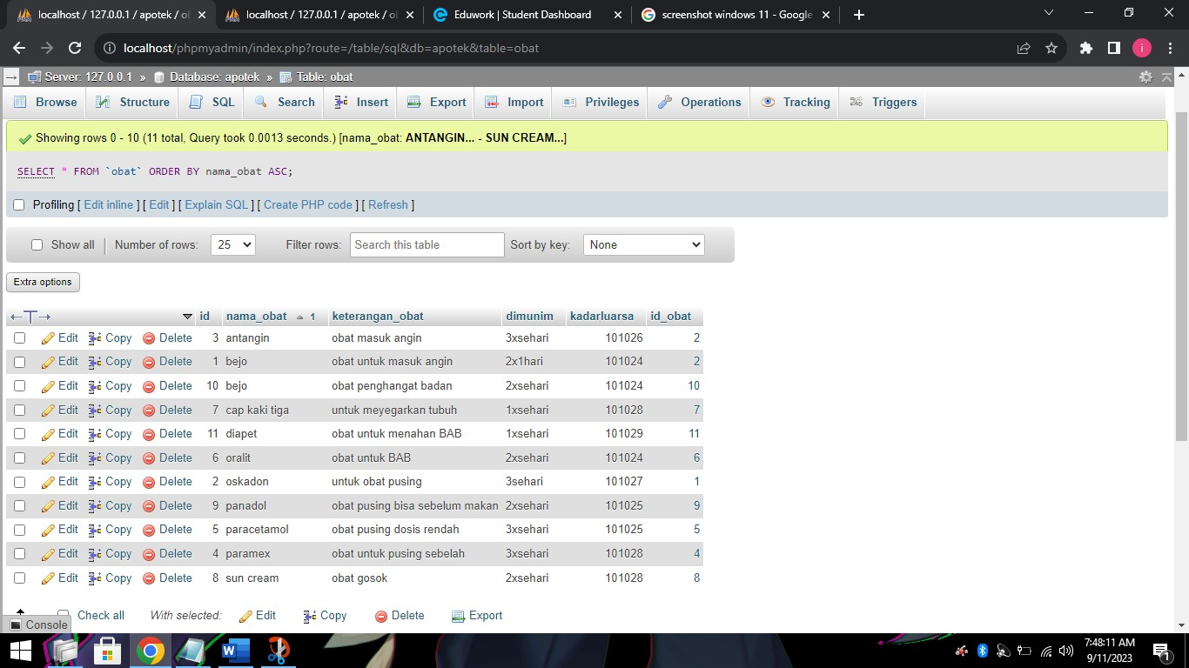

1. [SELECT](http://localhost/phpmyadmin/url.php?url=https://dev.mysql.com/doc/refman/8.0/en/select.html) \* FROM `obat` WHERE keterangan\_obat [LIKE](http://localhost/phpmyadmin/url.php?url=https://dev.mysql.com/doc/refman/8.0/en/string-comparison-functions.html%23operator_like) '%obat%';

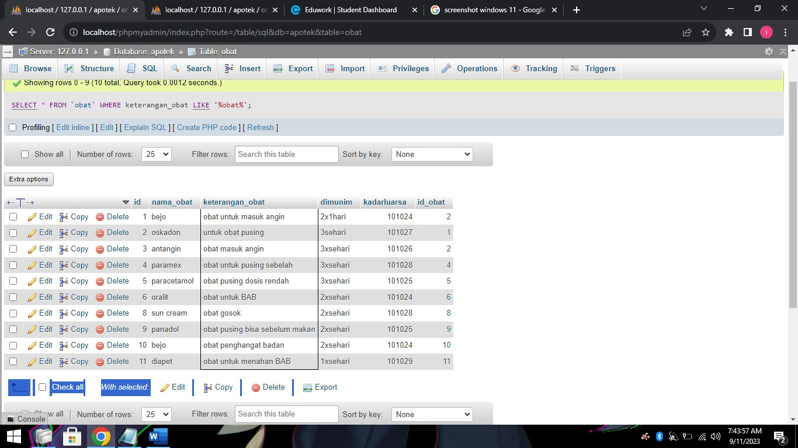

1. [SELECT](http://localhost/phpmyadmin/url.php?url=https://dev.mysql.com/doc/refman/8.0/en/select.html) \* FROM `obat` WHERE keterangan\_obat [LIKE](http://localhost/phpmyadmin/url.php?url=https://dev.mysql.com/doc/refman/8.0/en/string-comparison-functions.html%23operator_like) '%pusing%'

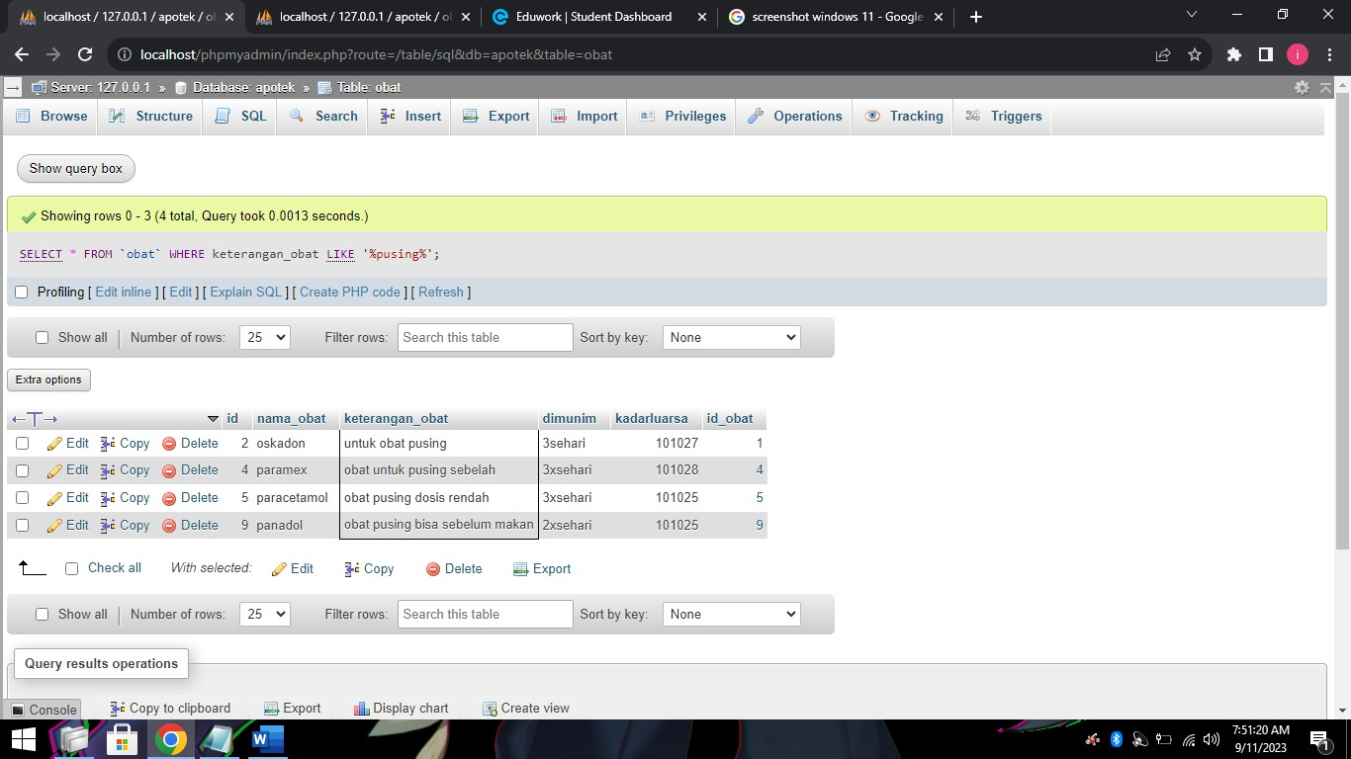

1. [SELECT](http://localhost/phpmyadmin/url.php?url=https://dev.mysql.com/doc/refman/8.0/en/select.html) nama\_obat, [SUM](http://localhost/phpmyadmin/url.php?url=https://dev.mysql.com/doc/refman/8.0/en/aggregate-functions.html%23function_sum)(qty\_stock) AS total FROM `obat` GROUP BY nama\_obat

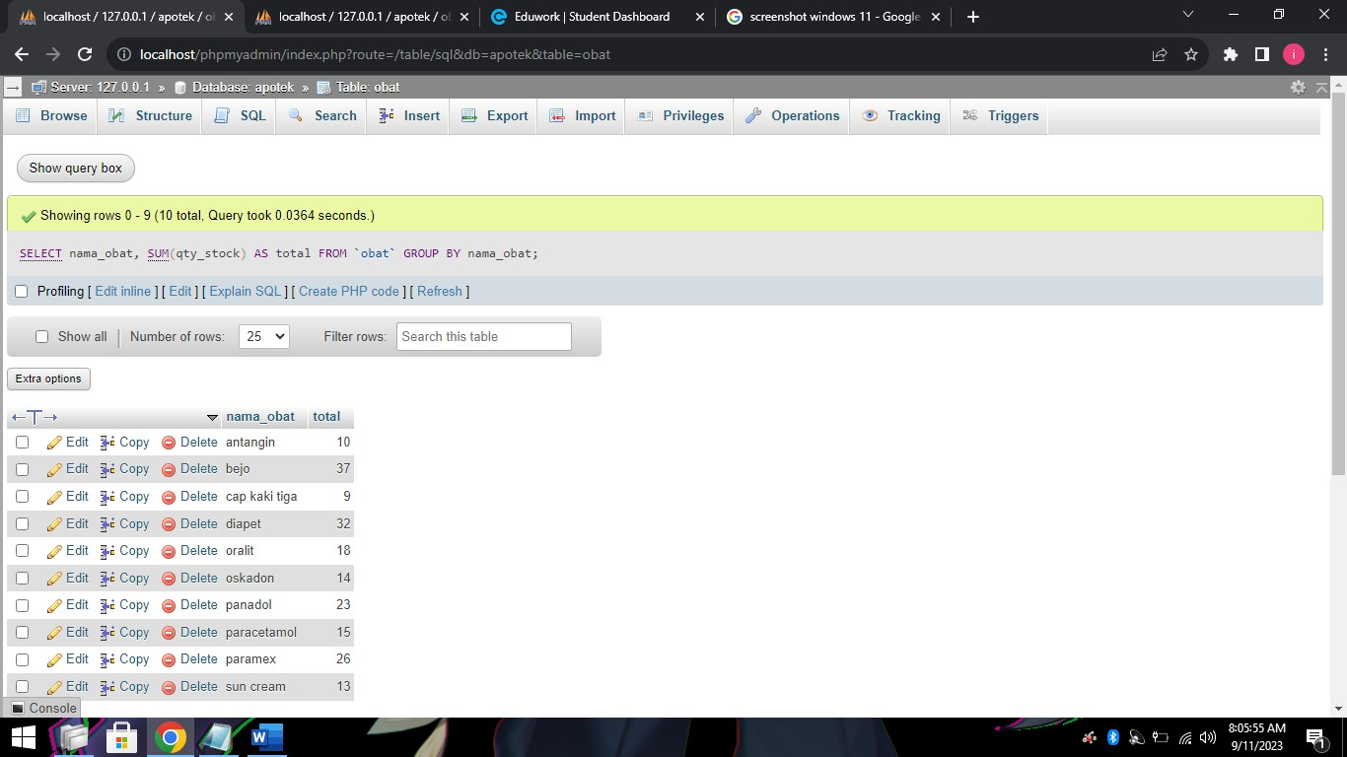

1. [SELECT](http://localhost/phpmyadmin/url.php?url=https://dev.mysql.com/doc/refman/8.0/en/select.html) keterangan\_obat, [SUM](http://localhost/phpmyadmin/url.php?url=https://dev.mysql.com/doc/refman/8.0/en/aggregate-functions.html%23function_sum)(qty\_stock) AS total FROM `obat` GROUP BY keterangan\_obat

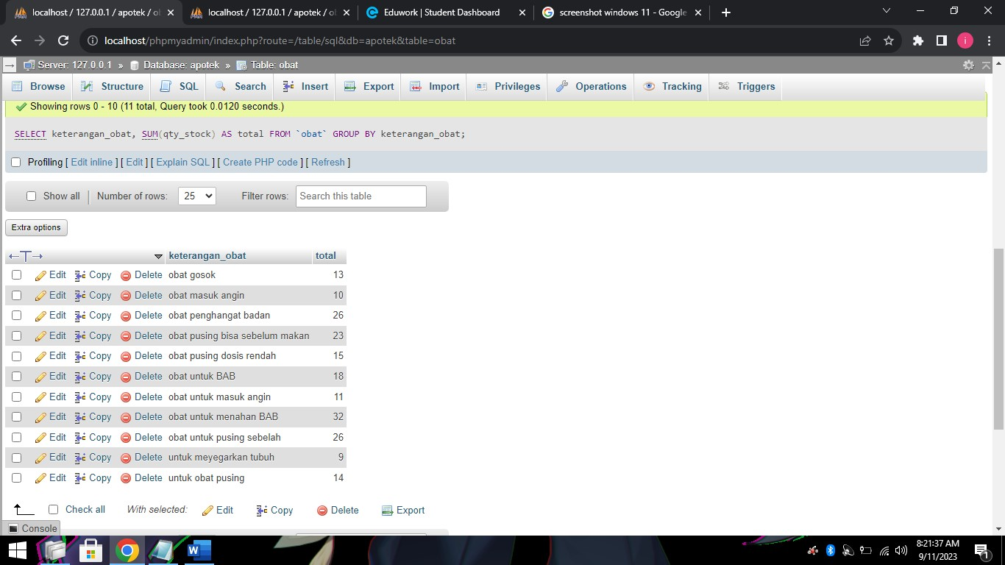

1. [SELECT](http://localhost/phpmyadmin/url.php?url=https://dev.mysql.com/doc/refman/8.0/en/select.html) kadarluarsa, [SUM](http://localhost/phpmyadmin/url.php?url=https://dev.mysql.com/doc/refman/8.0/en/aggregate-functions.html%23function_sum)(qty\_stock) as total FROM obat GROUP BY kadarluarsa

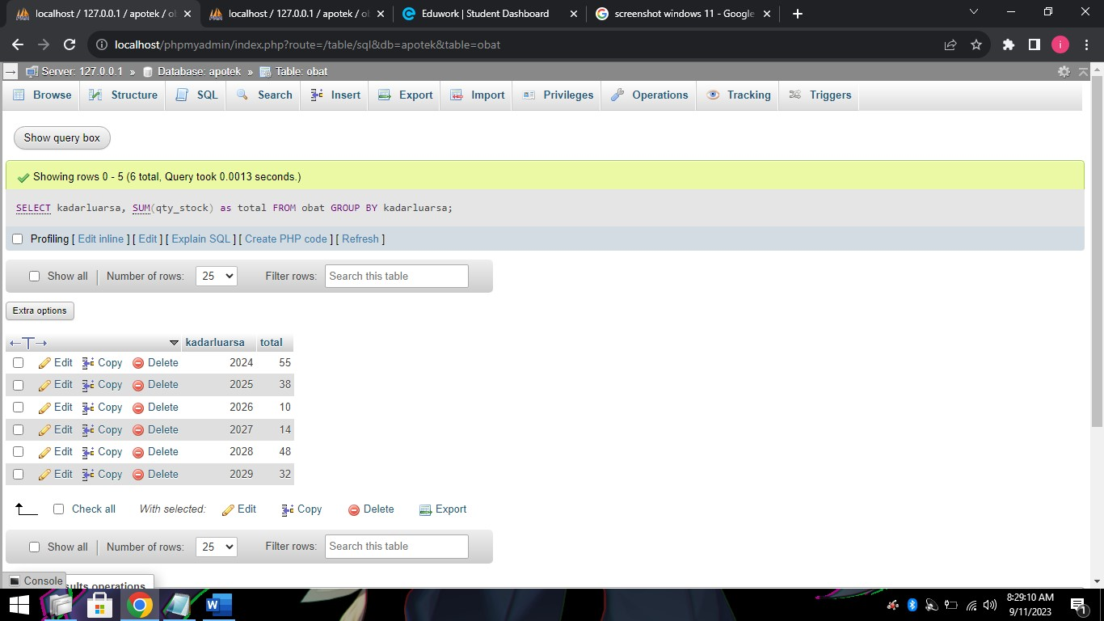

1. [SELECT](http://localhost/phpmyadmin/url.php?url=https://dev.mysql.com/doc/refman/8.0/en/select.html) kadarluarsa, [SUM](http://localhost/phpmyadmin/url.php?url=https://dev.mysql.com/doc/refman/8.0/en/aggregate-functions.html%23function_sum)(qty\_stock) as total FROM obat WHERE kadarluarsa >= 2025 GROUP by kadarluarsa ORDER BY kadarluarsa DESC

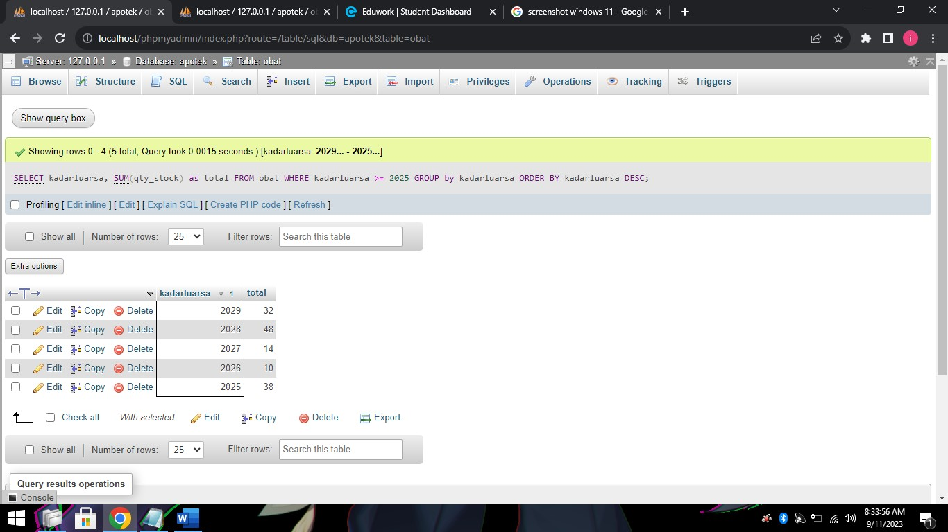

1. [SELECT](http://localhost/phpmyadmin/url.php?url=https://dev.mysql.com/doc/refman/8.0/en/select.html) kadarluarsa, [SUM](http://localhost/phpmyadmin/url.php?url=https://dev.mysql.com/doc/refman/8.0/en/aggregate-functions.html%23function_sum)(qty\_stock) as total FROM obat GROUP BY kadarluarsa ORDER BY kadarluarsa ASC

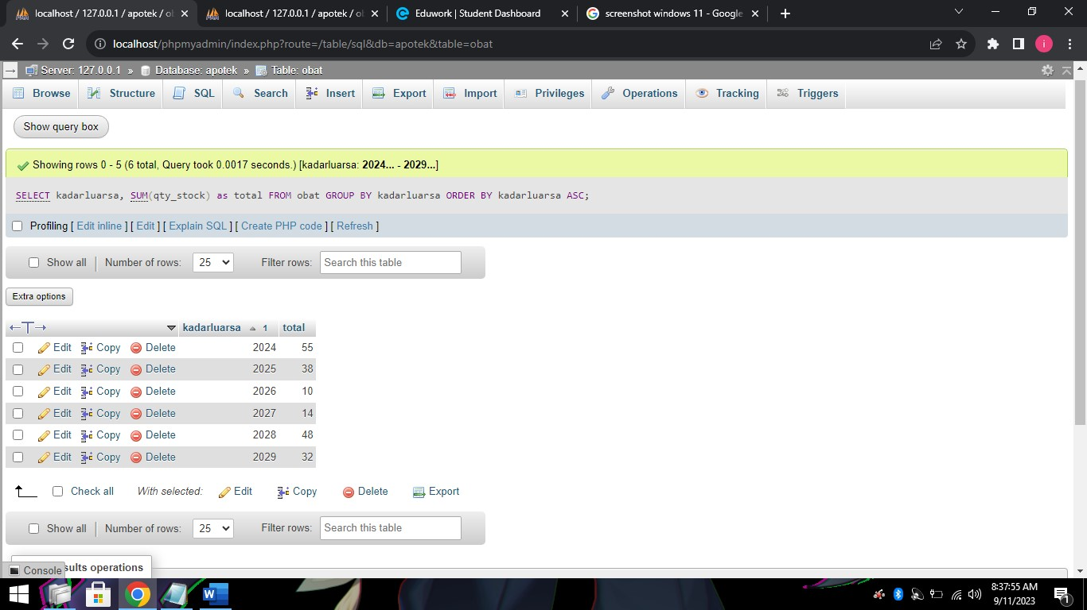

1. [SELECT](http://localhost/phpmyadmin/url.php?url=https://dev.mysql.com/doc/refman/8.0/en/select.html) kadarluarsa, [SUM](http://localhost/phpmyadmin/url.php?url=https://dev.mysql.com/doc/refman/8.0/en/aggregate-functions.html%23function_sum)(qty\_stock) as total FROM obat GROUP BY kadarluarsa ORDER BY kadarluarsa DESC

